

**TURTLE HATCHERY WEBSITE**

**INDIVIDUAL ASSIGNMENT**

**COMP40004**

**CF2321COM**

**Prepared by:**

**Sanu Abeygunawardana- CB011043**

**Date of submission:**

**Instructor: Ms. Prageeshaa Jayasinghe**

Table of Contents

introduction 7

Turtle Hatcheries in Sri Lanka 7

Designs 8

INDEX PADE 8

Index page design in Website 9

HOMEPAGE 10

Home page design on Website 11

CATEGORY PAGE 12

Category page in the Website 13

ABOUT US PAGE 13

About Us page in the Website 15

THREATS PAGE 17

threats page in website 18

OTHER HATCHERIES PAGE 20

Other hatcheries page 21

21

BENTOTA TURTLE HATCHERY PAGE 22

Bentota turtle hatchery page 23

23

KOSGODA TURTLE HATCHERY PAGE 25

Kosgoda turtle hatchery page 26

DONATE PAGE 28

Donate page 29

Validation Screenshots 30

Index page 30

Home page 31

Category 32

32

About Us page 33

Threats page 34

34

34

Other hatcheries page 35

Bentota hatchery page 36

Kosgoda hatchery page 37

37

Donate page 38

LINK 39

Conclusion 39

Table Of Figures

Figure 1 8

Figure 24 12

Figure 3 12

Figure 4 14

Figure 5 14

Figure 6 15

Figure 7 17

Figure 8 17

Figure 9 18

Figure 10 18

Figure 11 20

Figure 13 22

Figure 14 22

Figure 15 23

Figure 17 25

Figure 16 25

Figure 19 26

Figure 18 26

Figure 20 28

Figure 21 28

Figure 22 29

Figure 23 29

Figure 24 30

Figure 25 30

Figure 27 31

Figure 26 31

Figure 29 32

Figure 28 32

Figure 30 33

Figure 31 33

Figure 32 34

Figure 33 34

Figure 34 35

Figure 35 35

Figure 37 36

Figure 36 36

Figure 39 37

Figure 38 37

# introduction

### Turtle Hatcheries in Sri Lanka

Turtles around the countries are rescued and are taken care of by turtle hatcheries and other turtle protection research centers to prevent the extinction of sea turtles and to reduce the number of turtles who are victimized every year due to the actions done by humans and the phenomenal changes happening around the globe. The hatcheries create a comfortable and surviving habitat to sea turtles and other creatures as well. This following report follows a website about turtle hatcheries in Sri Lanka and their information.

# Designs

## INDEX PADE

### Index page design in Website

Figure

## HOMEPAGE

### Home page design on Website

Figure 3

Figure 2

## CATEGORY PAGE

v

v

v

### Category page in the Website

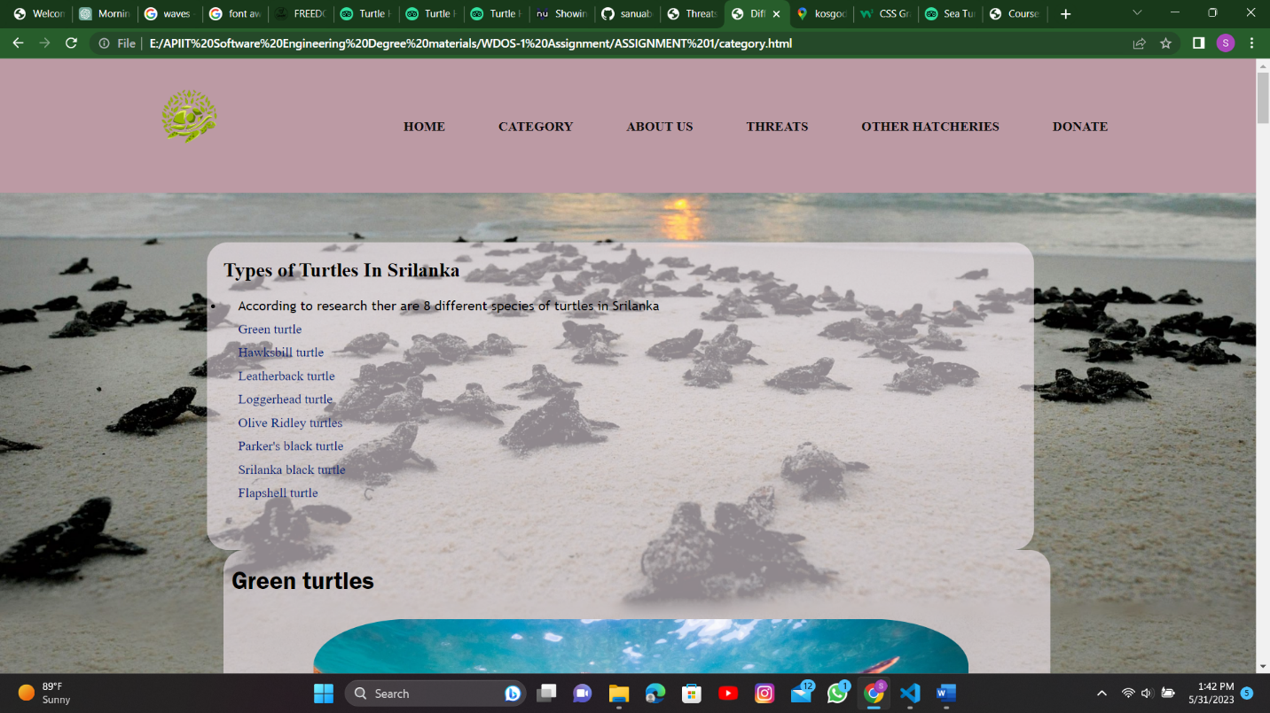

Figure 4

## ABOUT US PAGE

Figure

v

v

v

v

### About Us page in the Website

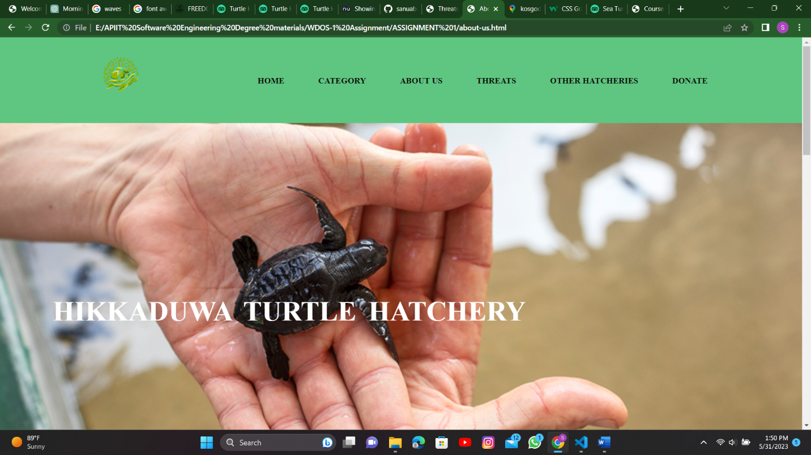

Figure

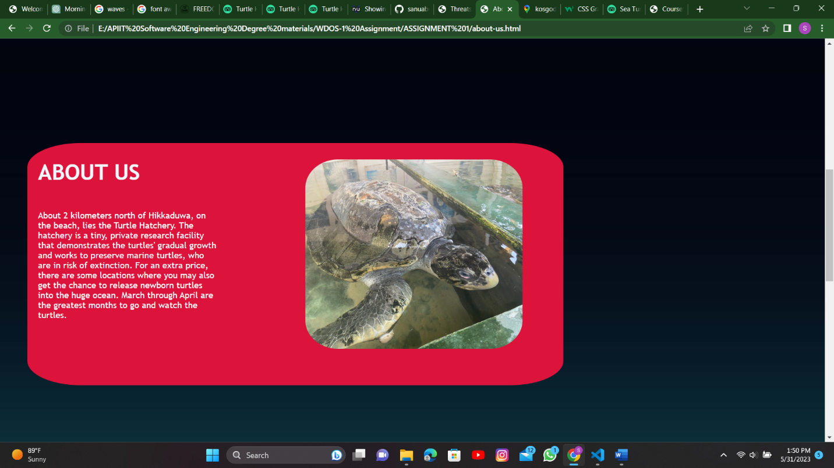

Figure

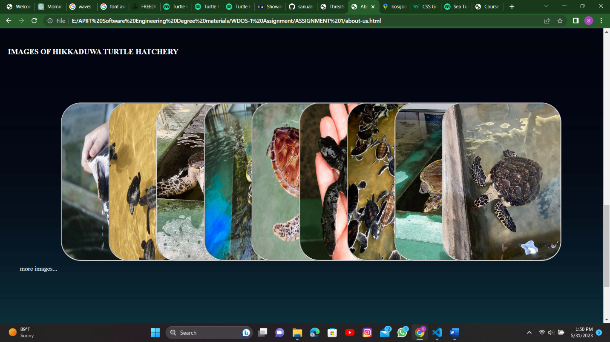

Figure

## THREATS PAGE

### threats page in website

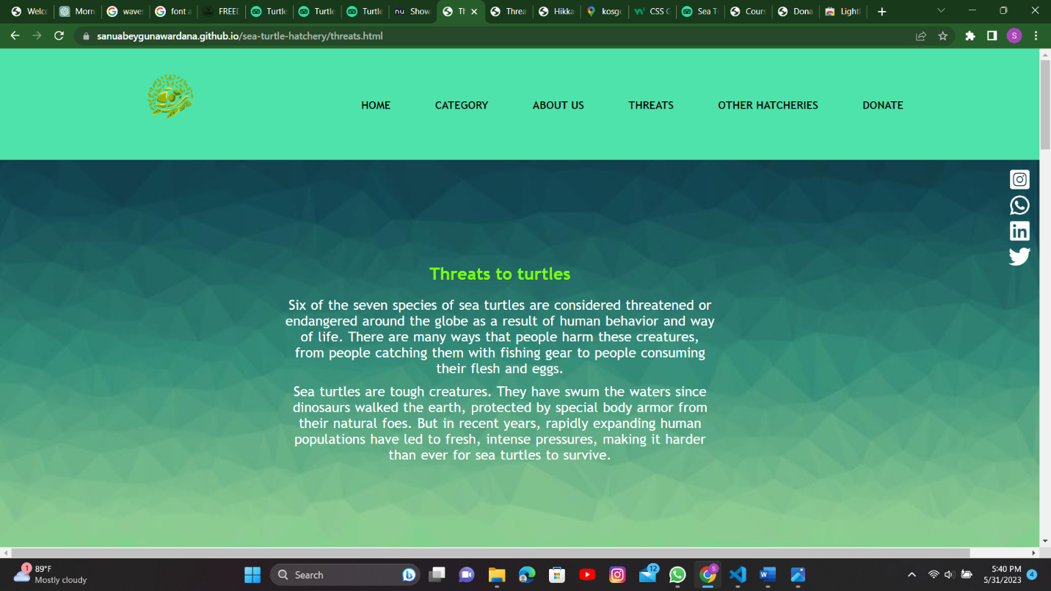

Figure

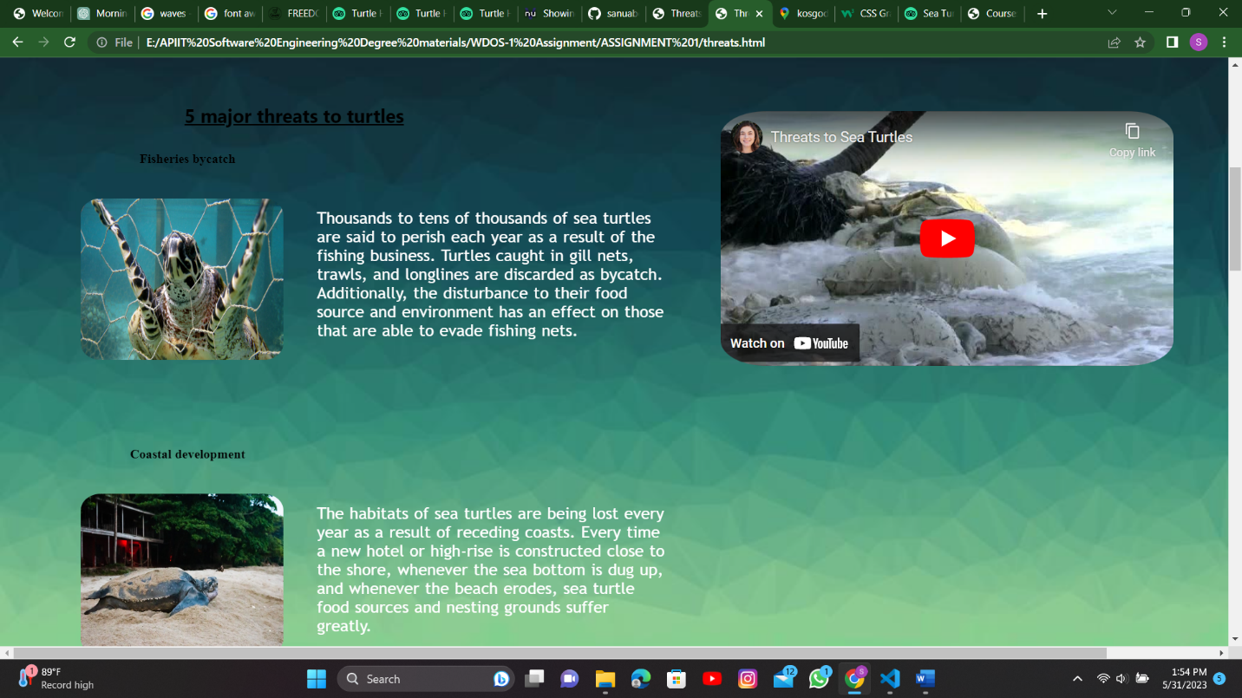

Figure

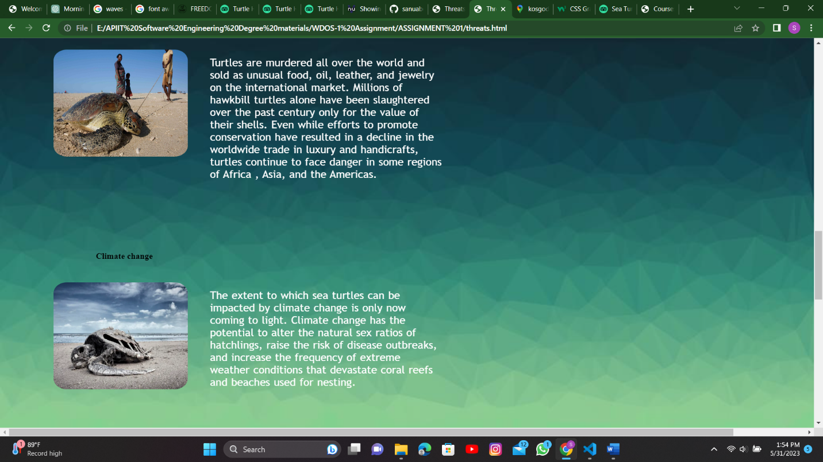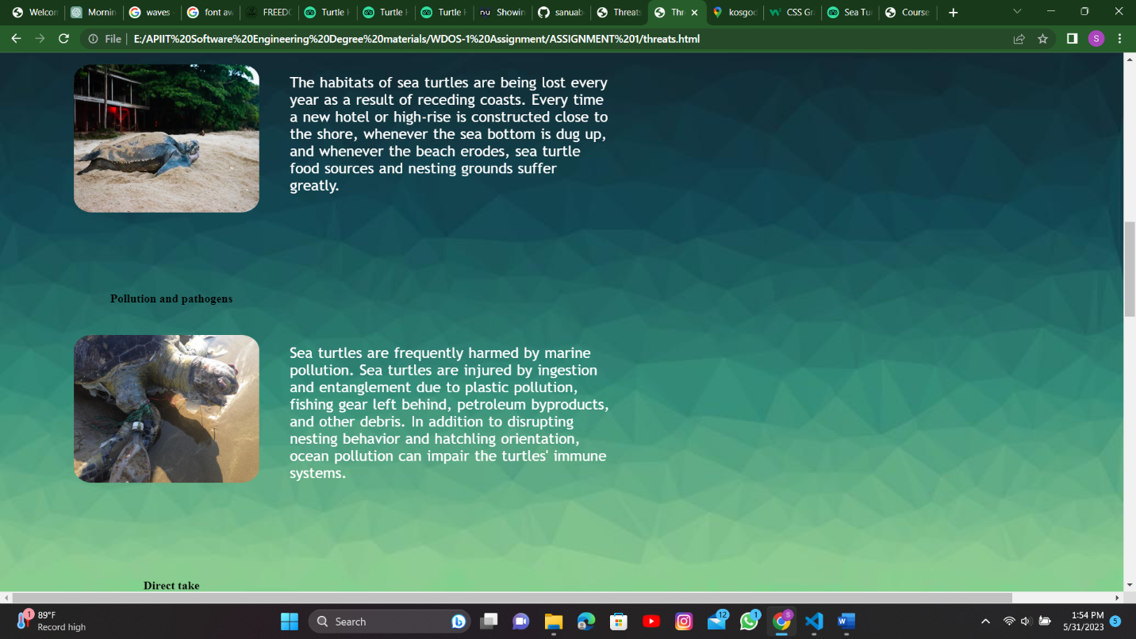

Figure

Figure

## OTHER HATCHERIES PAGE

### Other hatcheries page

### 

Figure

## BENTOTA TURTLE HATCHERY PAGE

### Bentota turtle hatchery page

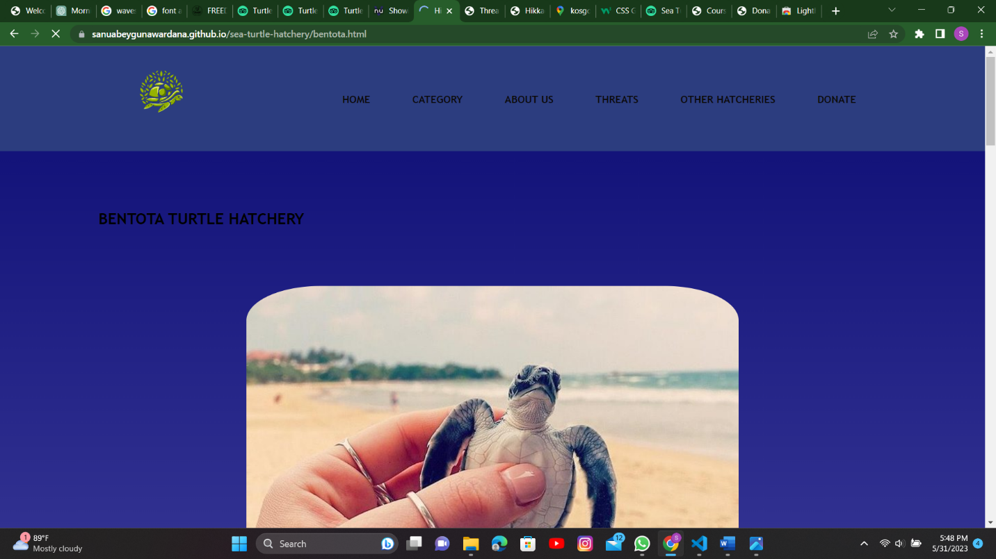

Figure

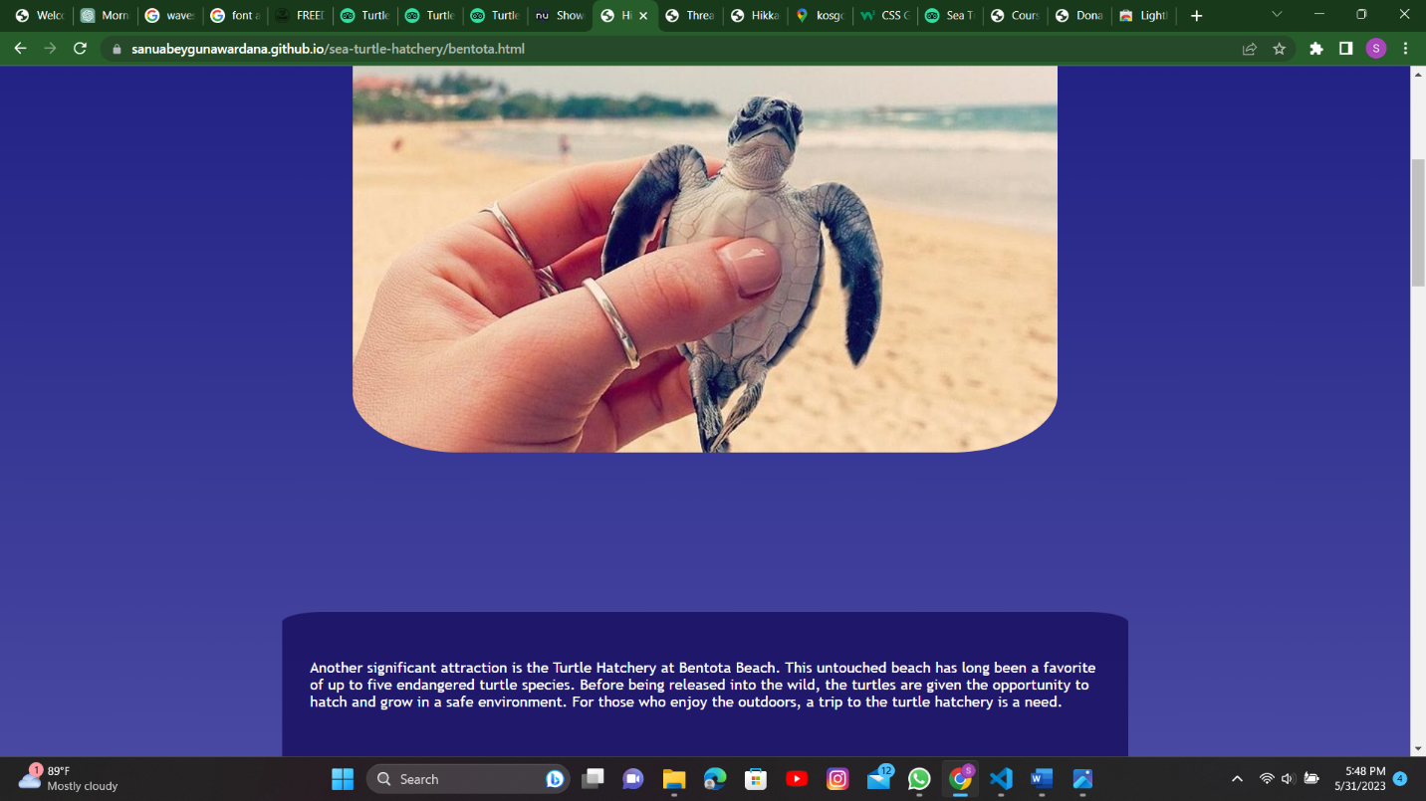

Figure

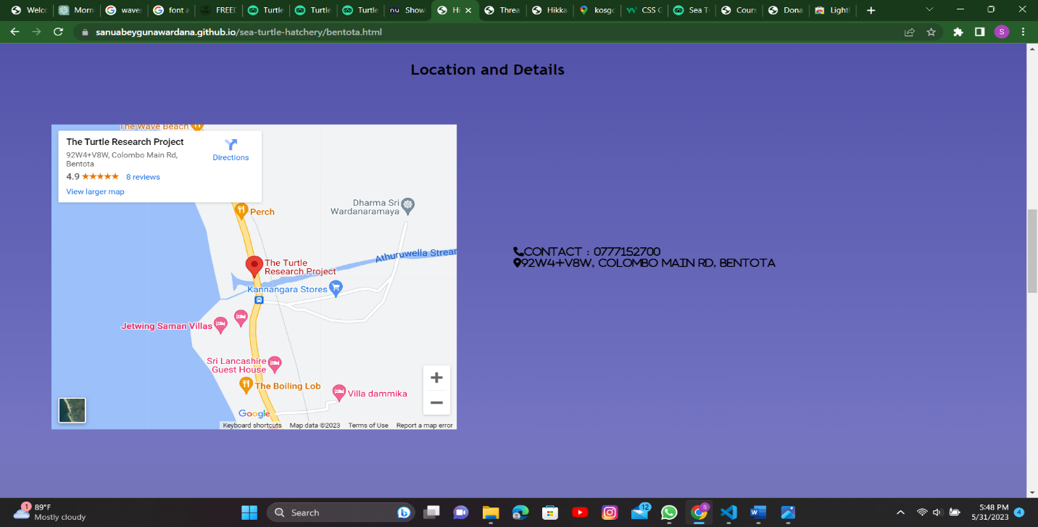

Figure

## KOSGODA TURTLE HATCHERY PAGE

### Kosgoda turtle hatchery page

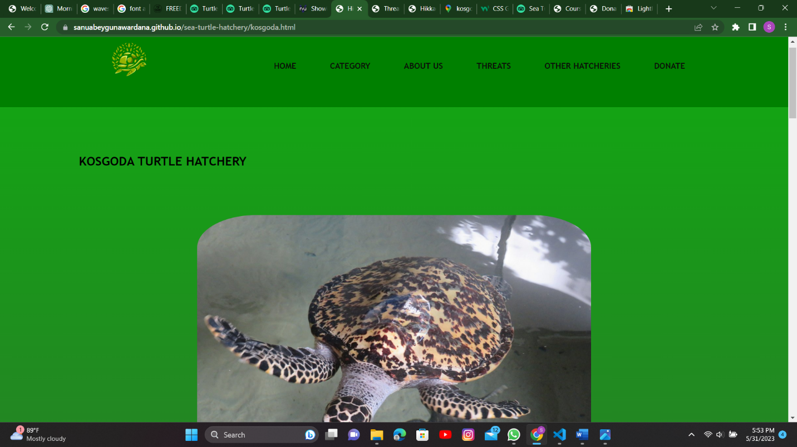

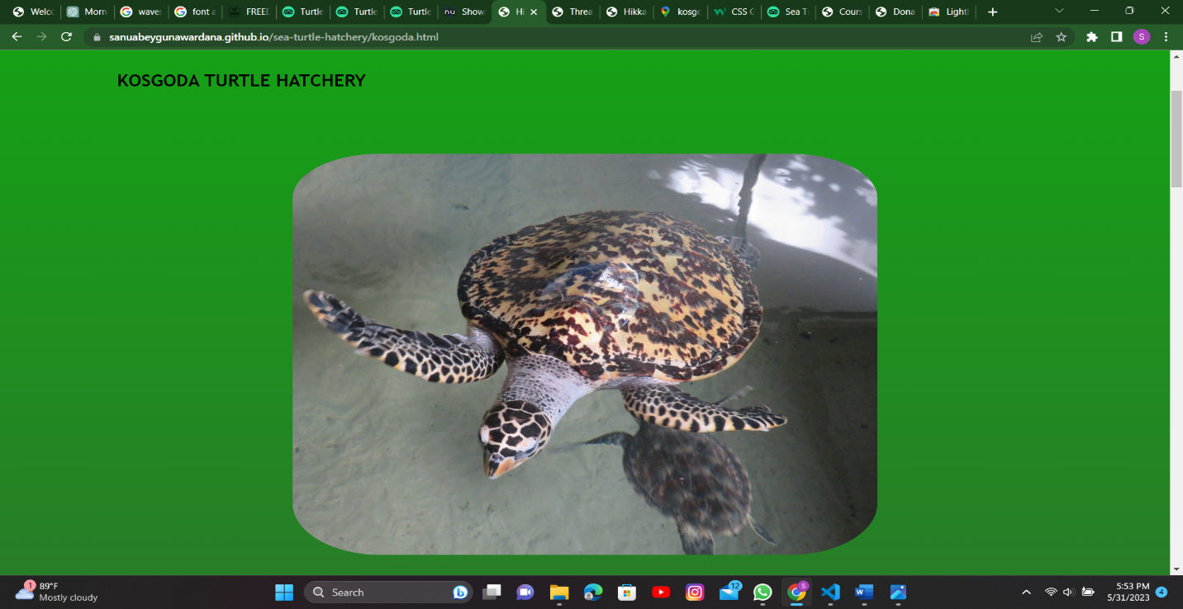Figure

Figure

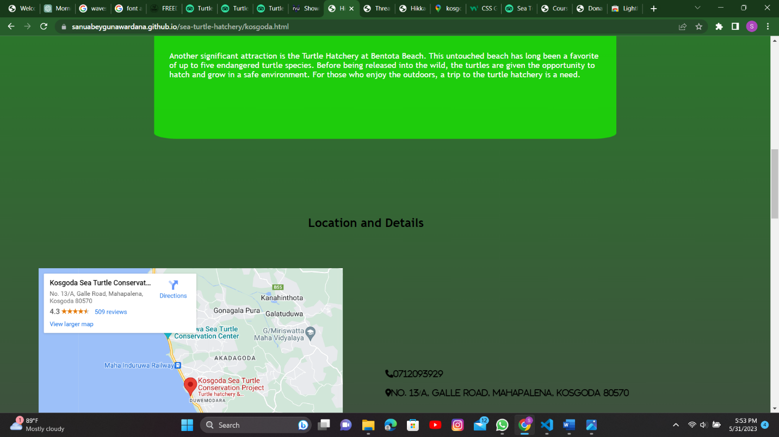

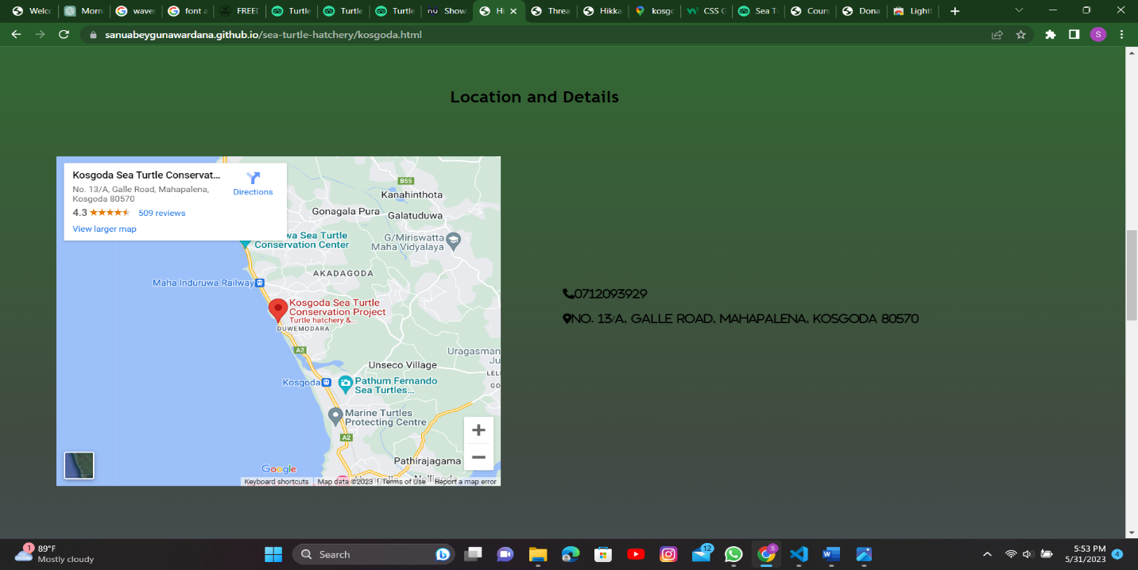Figure

Figure

## DONATE PAGE

v

### Donate page

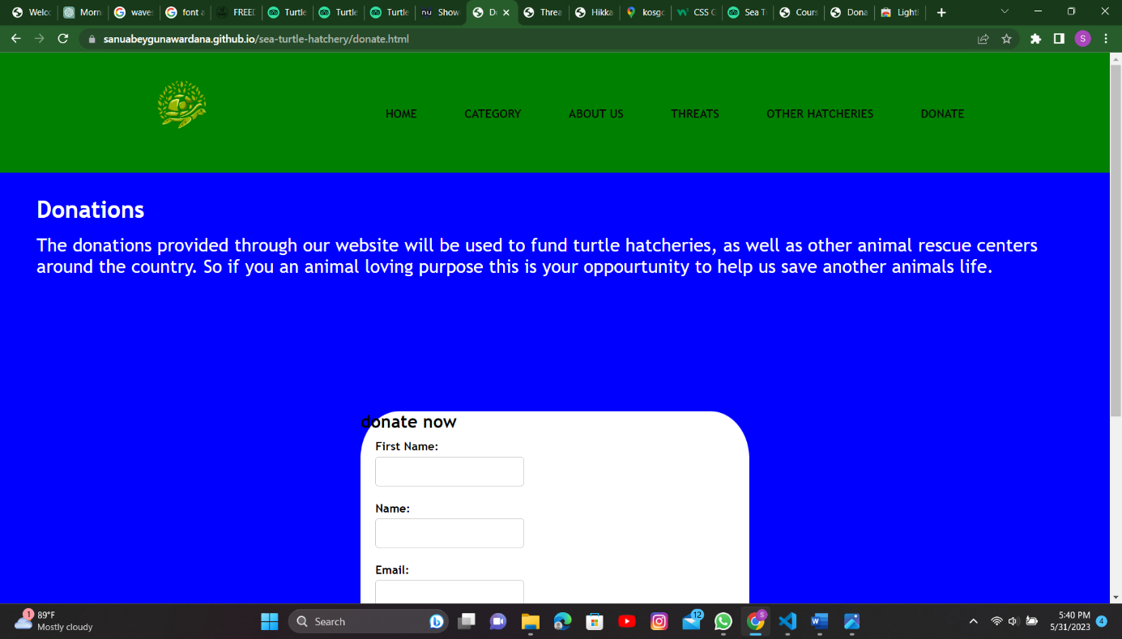

Figure

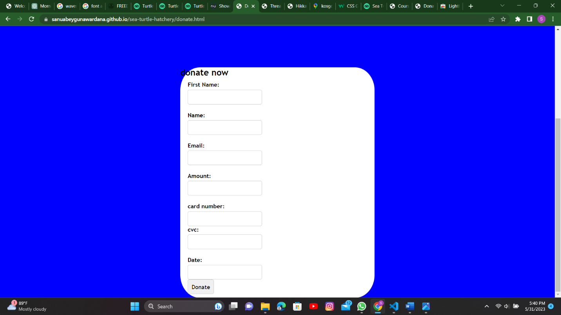

Figure

# Validation Screenshots

## Index page

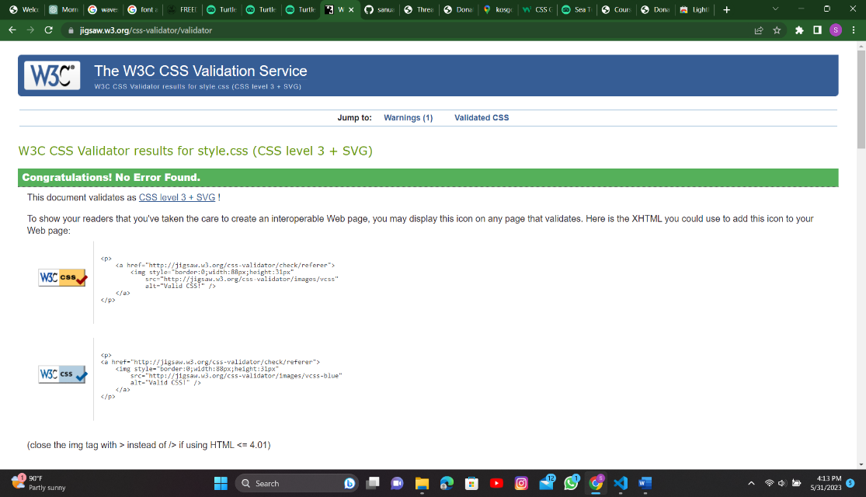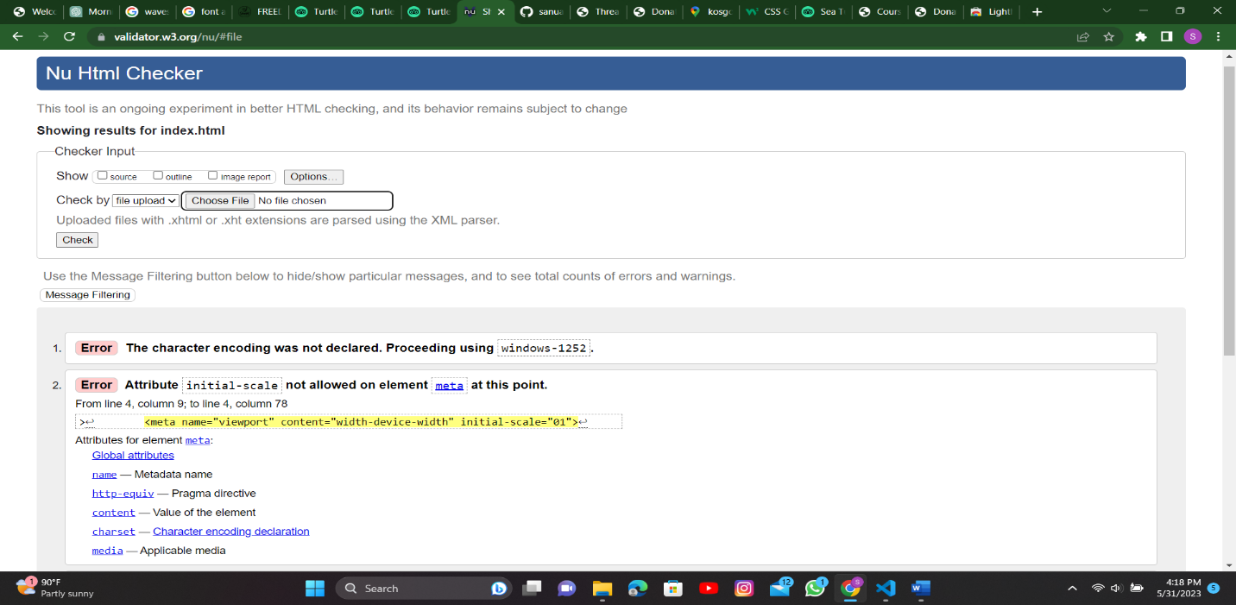

Figure

Figure

## Home page

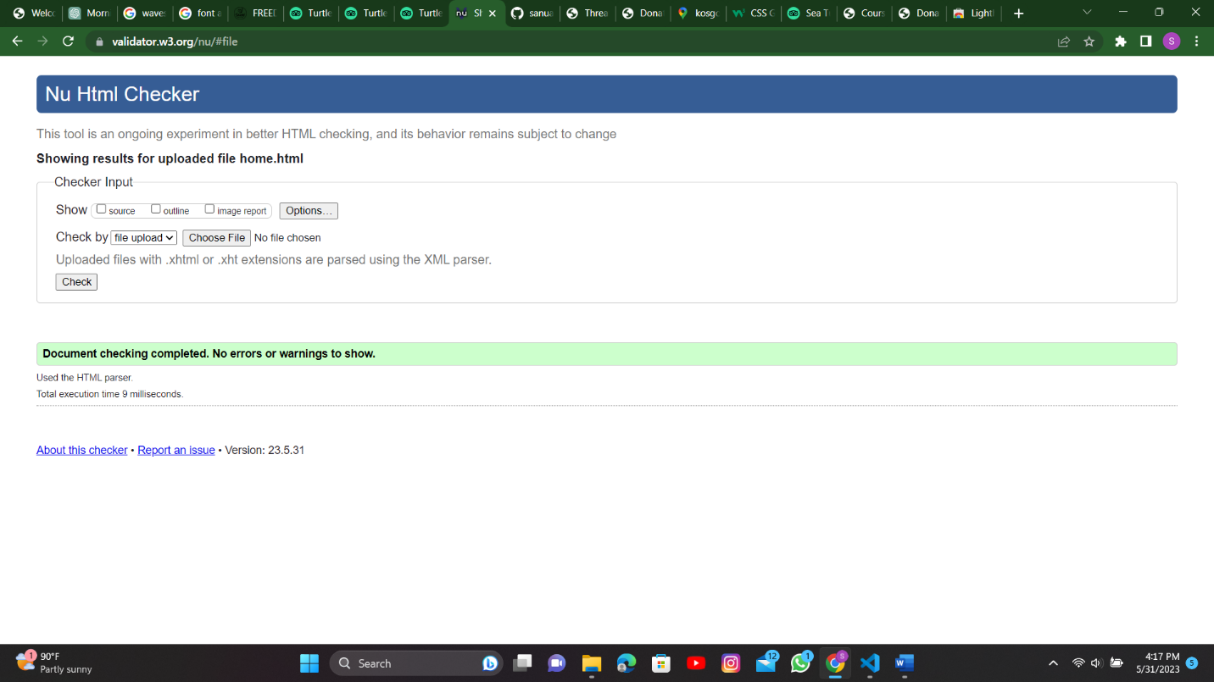

Figure

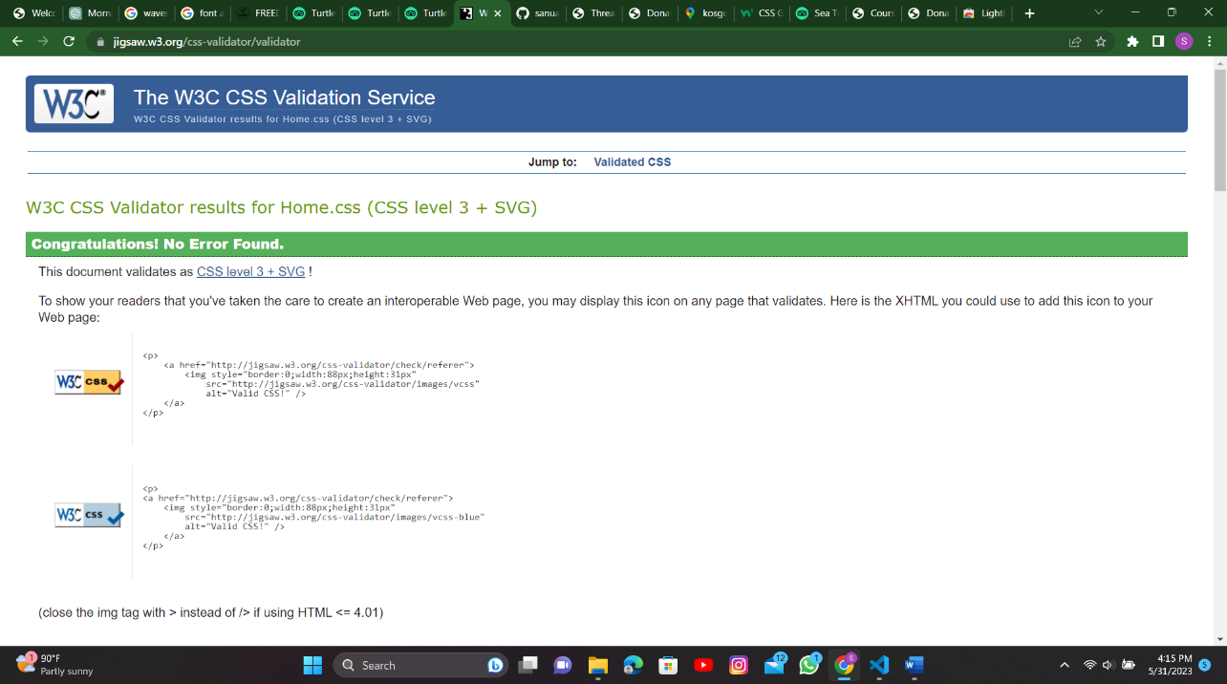

Figure

## Category

## 

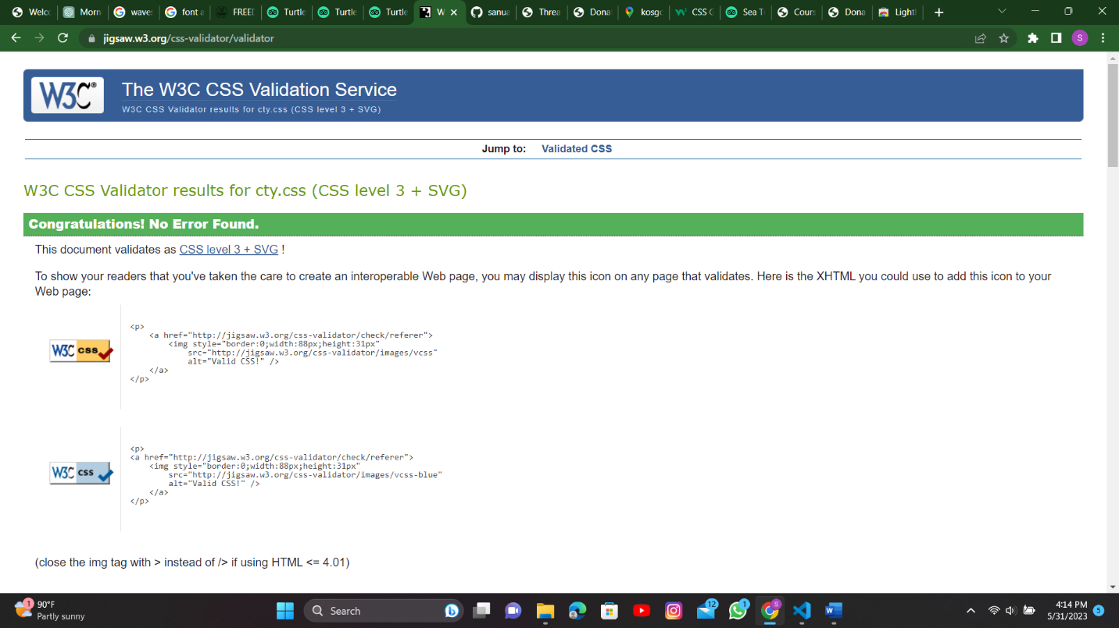Figure

Figure

## About Us page

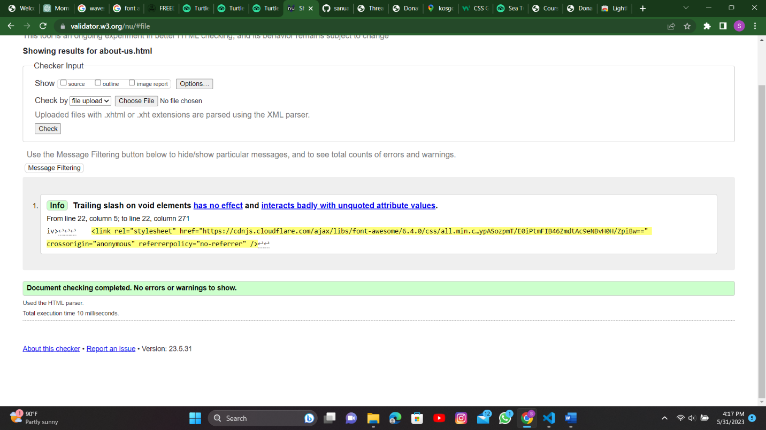

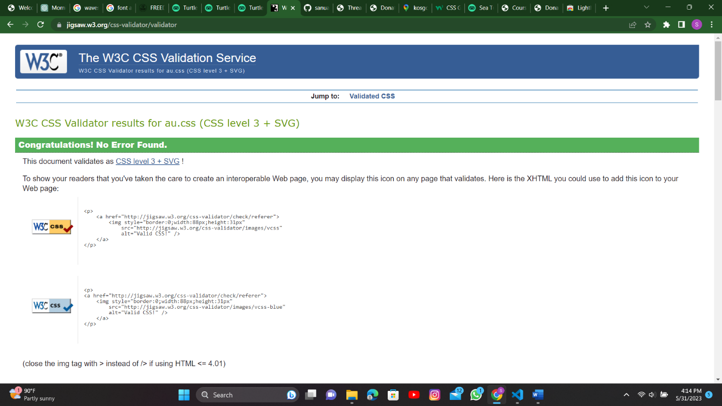Figure

Figure

## Threats page

## 

Figure

## 

Figure

## Other hatcheries page

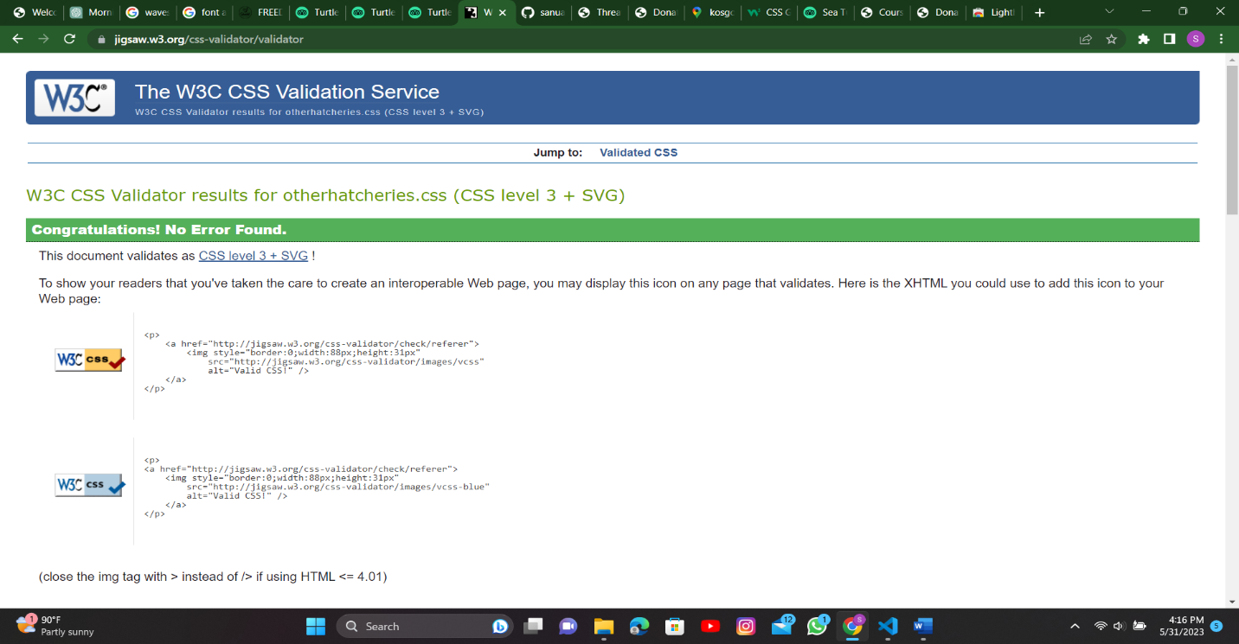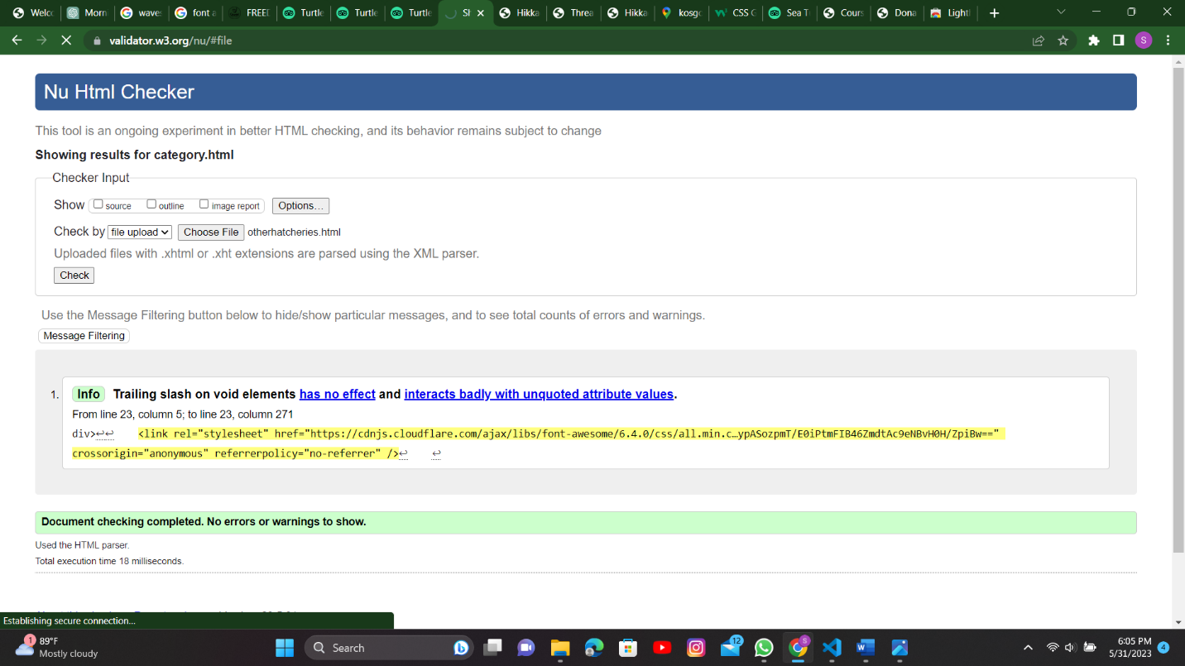

Figure

Figure

## Bentota hatchery page

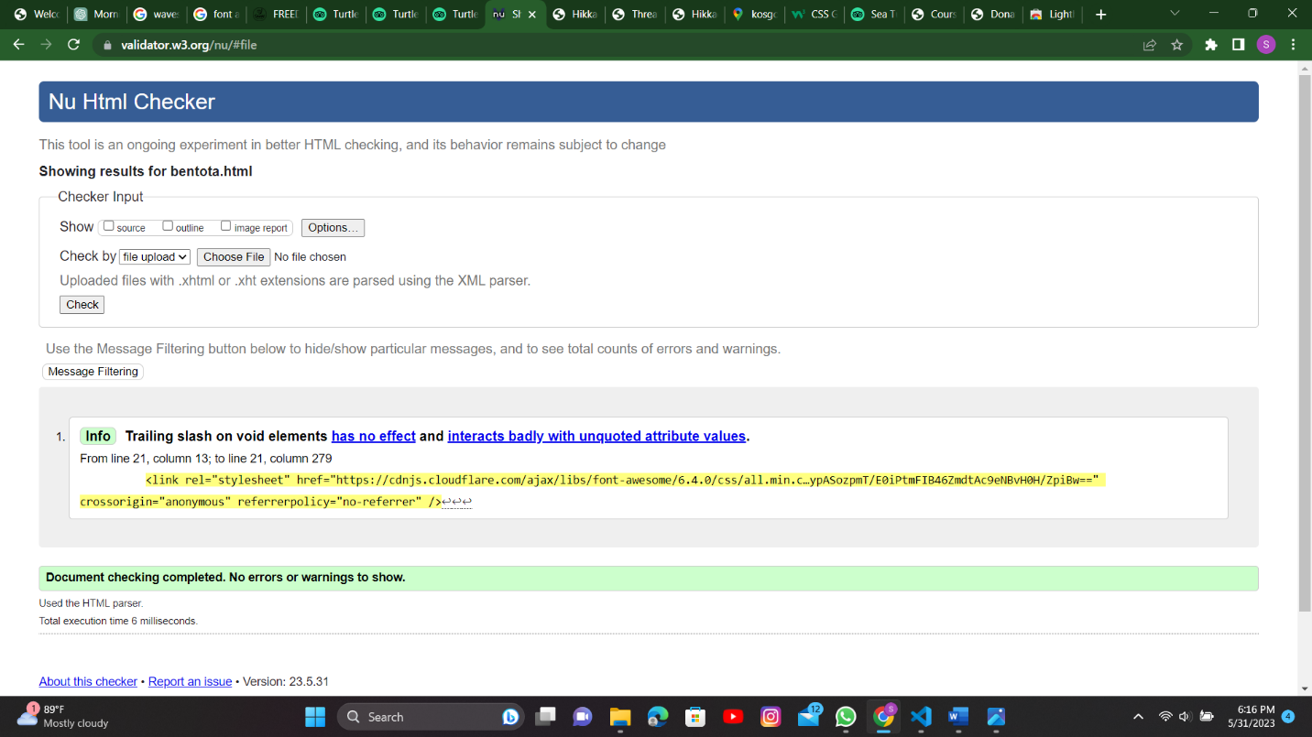

Figure

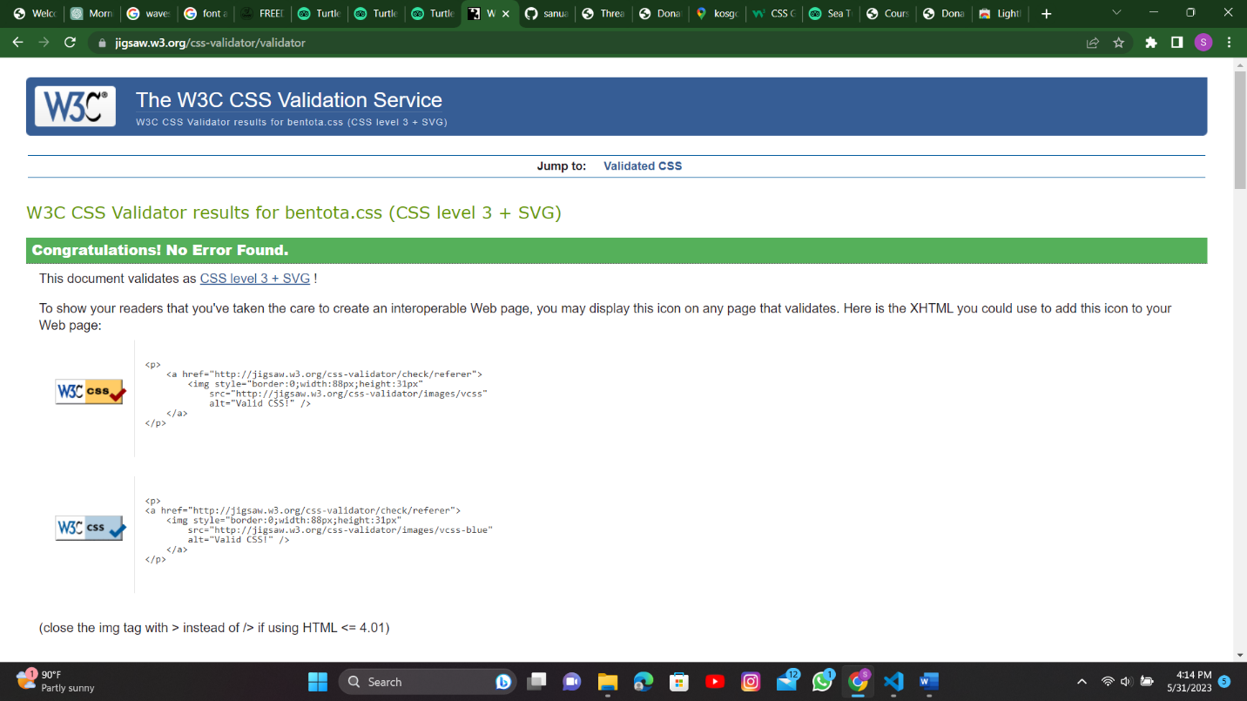

Figure

## Kosgoda hatchery page

## 

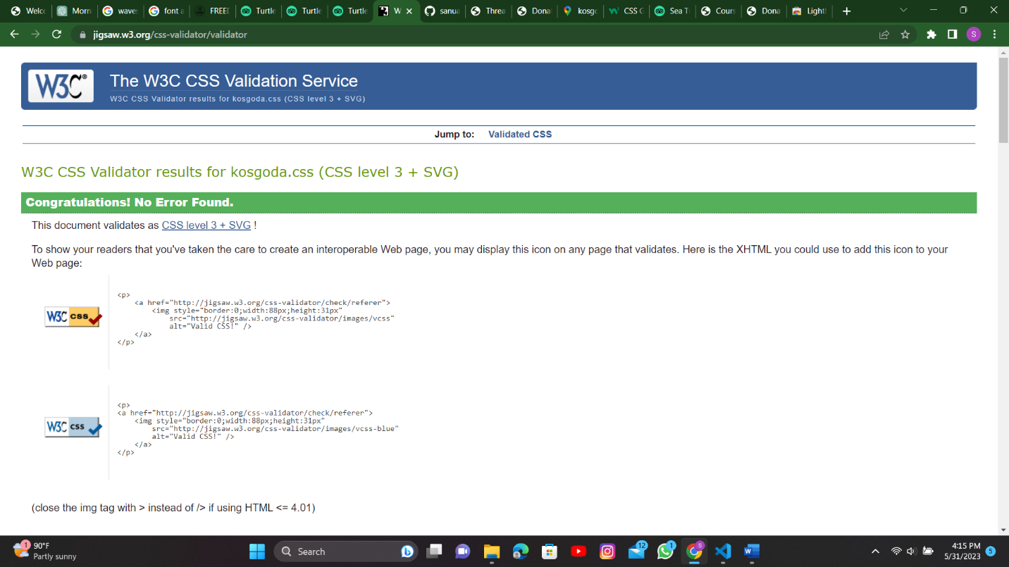Figure

Figure

## Donate page

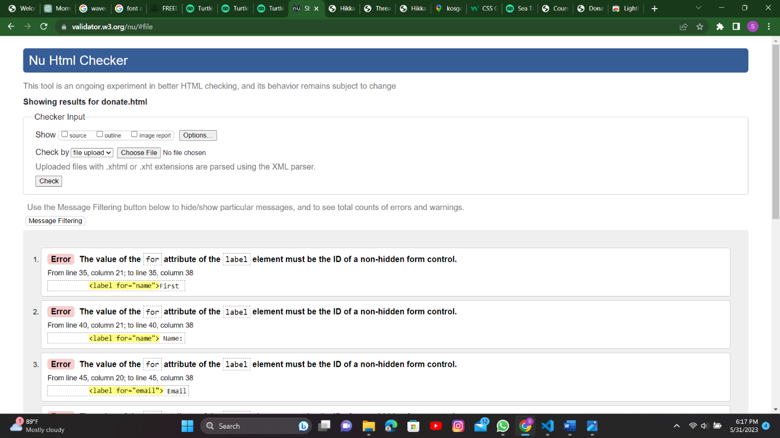

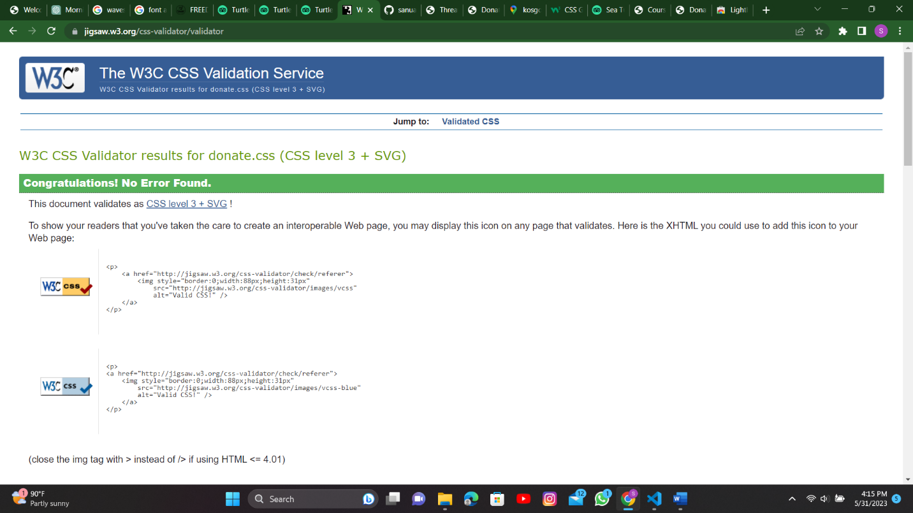Figure

Figure

# LINK

Link to host website: https://sanuabeygunawardana.github.io/sea-turtle-hatchery

# Conclusion

As stated in this report this website is allocated for a specific reason, and it is to increase the number of tourists and locals visiting the hatcheries. It will be a major factor to protecting these reptiles if the number of views increase every year. This website was created, hoping that it might pique the interest of those who care for animals and those who hope to be part of it.

# Referencing

(Anon., n.d.)

(Anon., n.d.)

(Anon., 2023)

(Anon., 2023)

(Anon., n.d.)

# References

Anon., 2023. *Haritha villas+Spa.* [Online]   
Available at: https://www.harithavillas.com  
[Accessed 20 May 2023].

Anon., 2023. *lakpura.* [Online]   
Available at: https://lk.lakpura.com/  
[Accessed 23 may 2023].

Anon., n.d. *Cannundrums.* [Online]   
Available at: http://cannundrum.blogspot.com  
[Accessed 20 May 2023].

Anon., n.d. *sun leisure world.* [Online]   
Available at: https://www.sunleisureworld.com  
[Accessed 24 may 2023].

Anon., n.d. *TripAdvisor.* [Online]   
Available at: https://www.tripadvisor.com  
[Accessed 31 may 2023].